

SMARTPHONE INSTRUMENTATION FOR COLLAPSE DETECTION OF BUILDINGS

A Mobile Crowd-Sourcing Approach Towards Earthquake Detection and Early Warning System

|  |
| --- |
| APPLIED COMPUTING PROJECT I & II SYSTEM DESIGN DOCUMENT |

|  |  |
| --- | --- |
| ZEYUN ZHU  2382881  zeyunzhu@gmail.com | HAEJONG DONG  2292191  s2haejong@gmail.com |
| PERTTU PITKÄNEN  2261724  perttu.pitkanen@student.oulu.fi | PRATYUSH PANDAB 2414775 pratyush.pandab@ee.oulu.fi |



# Abstract

Collapse of buildings is one of the primary causes of fatality in any earthquake. Although hi-fidelity seismic sensors stations are deployed for early detection of earthquake tremors, little effort has been put to detect collapse of buildings in real time. The post-earthquake period of detecting collapsed buildings mostly involve image processing of aerial photographs. This method introduces a significant delay between the time of occurrence of the actual ‘collapsing’ event and the time the Emergency Response Units (ERUs) are deployed, thus causing a rise in fatality rates.

To alleviate this response delay, we propose the design of a two-tier mobile client-backend server architecture that will uses a dense open crowd-sourced network of smartphones. The smartphones will act as distributed sensors that enable our system to monitor and detects collapse of buildings in real time whilst providing crucial location information. By exploiting the in-built accelerometer and gyroscope sensors of the smartphone our algorithms will detect the free-fall of smartphones during an earthquake. Depending on the number of smartphones that fall concurrently, our server will determine whether an ‘actual’ collapse of building has occurred. This being a time critical system, special attention is being given to the synchronization of the individual device clocks.

We have designed our system to cater to the needs of three different user groups - smartphone users, seismologists, and emergency service responders. To the subscribed users of our system, we shall broadcasts earthquake related warnings and alerts in real time, show them the location of collapsed buildings on the map, provide first-aid and safety information, and help them navigate using maps. As an added functionality, our system will allow users to participate in citizen journalism by providing effective tools to create and publish local news. Scientific researchers and seismologists will be able to monitor the health-status of all the registered smartphones, visualize aggregate accelerometer data from all smartphones, and check the location of collapsed buildings on a web-based dashboard. Meanwhile, ERUs will be alerted in real-time when a building collapses, to facilitate quick response.

Upon completion, an experimental evaluation of our system will indicate the feasibility and effectiveness of our approach when deployed in real life situations where users tend to have their smartphones on them. As false alarms have high costs associated with them, accuracy and reliability of our system is crucial and will be measured by the number of false positives.

# Acknowledgement

We would like to express our gratitude towards Professor Vassilis Kostakos for his expert guidance and continued support during the design phase. We also extend our thanks to Mr. Aku Visuri and Professor Timo Ojala for sharing his previous experience with similar projects and providing us with a concrete outline for the design document, respectively.

Table of Contents

Abstract

Acknowledgement

Table of Figures

Table of Tables

Glossary

Design process

*Research*

*Strategy*

*Implement*

State of the Art

*Towards cellphones and mobile devices:*

*Case Study*

Personas, Scenarios, & Use cases

*Requirements analysis*

*Personas*

*Scenarios*

*Use cases*

*Summary*

REquirements

*Original Requirements*

*Statement of Need (SON)*

*Functional and Non-functional requirements*

*User Interface requirements*

*Usability requirements*

System design

*Smartphones*

*AWARE Framework*

*Requirements Analysis*

Interface design

*Wireframes*

*Sketches*

Evaluation analysis

*Heuristic Evaluation*

*Web interface*

*Mobile interface*

Implementation (TODO)

Conclusion

References

Contributions

*Team Meetings:*

*Individual Contributions*

*Summary*

Appendix

# Table of Figures

Figure 1: User Centred Design Process [25]. We will iterate phases 3, 4, and 5 until a desired level of accuracy is reached

Figure 2. Persona 1. Dr. Susanna Hilbert is a 44 year old seismologist from Japan Meteorological Agency

Figure 3. Persona 2. Antti Makinen is a 22 year old exchange student in Tohoku University in Japan.

Figure 4. Use Case for Collapse Detection of Buildings (Overview)

Figure 5. Overview of the Collapse Detection System

Figure 6. AWARE infrastructure. It shows the Client and the Server components of AWARE system.

Figure 7. Collapse Detection System use case diagram

Figure 8. Class diagram of the Collapse Detection System

Figure 9. Sequence diagram of the Collapse Detection System

Figure 10. (Left) the hand drawn Mobile UI and (Right) the hand drawn Web UI

Figure 11. Mobile UI: Alert, Maps, and Maps with options

Figure 12. Post on Twitter, Post on Facebook, and posted successfully

# Table of Tables

Table 1. List of recent earthquakes in Japan with damage to residential buildings

Table 2. Causes of deaths in the recent earthquakes in Japan

Table 3. Comparison of fatalities in the Loma Prieta and Northridge earthquakes

Table 4. Zeyun Zhu working hours

Table 5. Hejong Dong working hours

Table 6. Perttu Pitkänen working hours

Table 7. Pratyush Pandab working hours

Table 8. Summary table of total work load and individual contributions

# Glossary

This section provides a brief explanation of the terms relating to the system design document and the project in general. The terms are alphabetically ordered.

#### Cardiopulmonary resuscitation (CPR)

Cardiopulmonary resuscitation, commonly known as CPR is a first aid technique that can be used if someone is not breathing properly or if their heart has stopped [1].

#### Earthquake and Epicenter

An earthquake is the shaking and vibration of the Earth's crust due to movement of the Earth's plates (plate tectonics). Plates do not always move smoothly alongside each other and sometimes get stuck. When this happens pressure builds up. When this pressure is eventually released, an earthquake tends to occur.

The point inside the crust where the pressure is released is called the focus. The point on the Earth's surface above the focus is called the epicenter [2].

#### Micro-Electro-Mechanical Systems (MEMS)

Micro-Electro-Mechanical Systems, or MEMS, is a technology that in its most general form can be defined as miniaturized mechanical and electro-mechanical elements (i.e., devices and structures) that are made using the techniques of micro-fabrication. While the functional elements of MEMS are miniaturized structures, sensors, actuators, and microelectronics, the most notable elements are the micro-sensors and micro-actuators [3].

#### Modified Mercalli Intensity scale (MMI)

The Mercalli intensity scale is a seismic scale used for measuring the intensity of an earthquake. This scale is composed of increasing levels of intensity that range from imperceptible shaking to catastrophic destruction. It is designated by Roman numerals. It does not have a mathematical basis; instead it is an arbitrary ranking based on observed effects. The lower numbers of the intensity scale generally deal with the manner in which the earthquake is felt by people. The higher numbers of the scale are based on observed structural damage [4].

#### Richter scale

An earthquake's power is measured on the Richter scale (a logarithmic scale) using an instrument called a 'seismometer'. The Richter scale is numbered 0-10. Earthquakes measuring just one or two on the scale are very common and can happen every day in places like San Francisco. These earthquakes are so small that people cannot feel them, they can only be picked up by a seismometer. Meanwhile, earthquakes measuring around 7 or 8 on the Richter scale can be devastating. For instance, the earthquake in China's south-western Sichuan province in May 2008 measured 7.8 on the Richter scale [2].

#### Seismometer

A seismometer is a device designed to measure movement in the Earth. Seismometers are typically used to measure seismic waves originating from an earthquake or explosion, and traveling through the ground as waves of force in the rocks and soil [5].

#### Two-tier architecture

A two-tier architecture refers to client/server architectures in which the user interface runs on the client and the database is stored on the server. The actual application logic can run on either the client or the server. In our system, the application logic runs both on the client and on the server [6].

#### User Centred Design (UCD)

User-Centered Design (UCD) is the process of designing a system, from the perspective of how it will be understood and used by a human user. Rather than requiring users to adapt their attitudes and behaviors in order to learn and use a system, a system can be designed to support its intended users’ existing beliefs, attitudes, and behaviors as they relate to the tasks that the system is being designed to support [7].

# Design process

The following section constitutes the planning phase of our design. It is often an important step towards problem solving. We have chosen a User Centred Design approach towards exploring our problem and solution space. Our design approach can be summarized using Figure 1.



## Research

The research phase was dedicated towards a breadth wise investigation of the problem domain. During this phase we focused on the following,

1. Learn about stakeholders
   1. Identify primary and secondary stakeholder
2. Discover Goals and Needs
   1. What are the requirements?
3. How is it done now?
4. What is wanted?
5. What else has been tried?
6. Is there already another solution?

Each of the above were considered as a within-team deliverables for discussions during team meetings. All team members contributed equally to this phase. During meetings individual ideas were scrutinized, filtered, refined, and finally summarized to generate a cohesive result.

## Strategy

The next phase was to ideate and brainstorm. The previous phase had generated a huge amount of information which were not necessarily relevant to our problem space. Hence, we brainstormed to isolate relevant ideas, discuss the issue at hand, and identify potential solution. It was during this phase that we designed personas and scenarios followed by the building of UML use case and sequence diagrams. We spent a considerable amount of time in this phase. The workload was equally distributed among the team members and within-team deliverable deadlines were assigned to each.

## Implement

The implement phase was dedicated for prototyping and system architecture design. Initially hand-drawn wireframes were prepared followed by a quick and dirty expert evaluation using Nielsen’s heuristics [8]. We addressed the identified usability issues and transferred the new designs onto the Axure platform [9] for generating interactive prototypes.

In retrospect, by adhering to our UCD process from Figure 1, we have completed the first and the second phase. The thirst phase, i.e., Implement, is half-way. The second half will include the programming implementation. Our next ACP deliverable shall explain the latter part of this phase in conjunction with agile model.

The rest of the document explores the possibilities of achieving our goal of near real-time monitoring of the health status of buildings to detect any immediate collapse of buildings during an earthquake event. In summary, using an exploratory approach, we first identified the stakeholders of our system, and designed their Statement of Need (SON) to describe their goals. This being an UCD approach, we also built personas and their scenarios to explain ideal and non-ideal usage of the system. Based on the scenarios and refinement of the SONs we arrived at concrete functional requirements which paved the way for designing the Use Cases for the system. Each use case was further explored in a detailed sequence diagram, followed by its corresponding class diagrams. Later we present the proposed user interface elements expected in the system followed by results of an expert evaluation. We conclude the report by providing a realistic estimation of time spent on the design document and our individual contributions.

# State of the Art

The most common information available immediately following a catastrophic event such as an earthquake is its magnitude and epicenter location. However, an accurate and a full extent of the damage assessment requires time and is currently mostly provided by estimates. For instance, the full extent of the damage from the 1995 Kobe earthquake, Japan, was not recognized by the central government in Tokyo until many hours later.  This greatly affected the rescue and recovery operations. Products such as ‘ShakeMaps’ [10] come close to the rescue by providing near real-time estimates using the sensors that are available from traditional seismic networks such as the Southern California Seismic Network (SCSN). A trade-off associated with these hi-fidelity seismic sensors is its sparse distribution (approximately 10 km in case of SCSN [11]) resulting in maps of low-resolution. Increasing the density of such hi-fidelity networks beyond that is needed for its basic function of locating the earthquake epicenter is cost prohibitive. The cost factor has been partially addressed by the use of open-network of low-cost microelectromechanical systems (MEMS) sensors that are hosted by volunteers [11]. However, the count of actual collapse of buildings and fatality is not obvious from these methods.

Another popular approach towards obtaining earthquake measurements data is the use of crowdsourcing. The “Did You Feel It” (DYFI) product of the US Geological Survey does this with a simple post-earthquake questionnaire [12] . The form of the questionnaire and the method for assignment of intensities are based on an algorithm developed by Dengler and Dewey for determining a "Community Decimal Intensity" [13]. Recent mild but widely-felt earthquakes in Los Angeles region have produced over 40,000 entries; supporting the likelihood of the popularity of such systems. However, this system has its caveats. One drawback of this form of sensing is that the human responders in the areas of heavy shaking usually do not make the data entry their first priority, and hence information from the most critical areas is usually late. Further, as this method of sensing requires users’ attention during times of peril, they could be considered hazardous in nature.

## Towards cellphones and mobile devices:

Smartphones have lately become ubiquitous in today’s society. They are equipped with multiple MEMS sensors, such as accelerometer, gyroscope, light, pressure, etc. [14], powerful onboard microcontrollers, and capacious memory; thus increasingly being viewed as handheld computers. Though the quality of these sensors is not at par with that of the hi-fidelity stationary sensors, their precision is increasing on-demand. With the plethora of apps and an open source platform for developing them, the functionalities of these handheld devices can be enhanced or modified to suit any specific need.

In this design document we describe a novel way to achieve the goal of near real-time monitoring of the health status of buildings to detect any immediate collapse during an earthquake event. The method is based on mobile crowdsourcing that utilizes the inbuilt accelerometer sensors of smartphones to detect a ‘Fall/Collapse’ event, followed by near real-time data analysis on a backend server to determine whether a building has “actually” collapsed. The primary goal of our system is to sense earthquakes as they are happening and detect any collapsed buildings accurately and reliably using smartphones within minutes. Smartphone users will be able to receive alerts related to building collapse and act accordingly. Further, seismologists/researchers will be able to collect necessary seismic data for any relevant processing.

One of the obvious challenges faced with implementation of the above mobile crowd-sourced system is separating the “unpredictable” human component which is often associated with any form of personal handheld device, particularly smartphones. One straightforward solution is to detect when the phone is at rest, and only use data from the sensors when in this state. A similar approach has been previously used by the ‘iShake’ system [15], which uses in-built smartphones’ accelerometer to monitor ground motion activity, only during inactive state.

## Case Study

January 17 at 5:46 a.m. 1995, The Kobe Earthquake hit a highly populated area of about two million population while most people were sleeping. It was known as “The great Hanshin earthquake” and was the first time in the world that a densely populated modern city area was directly hit by very strong ground shaking. Over five thousand people were killed mostly due to collapse of houses. This disaster was warned by Coburn that “The primary cause of deaths in the world is still collapse of buildings” [16], [17] moreover, an important lesson from the Kobe Earthquake is the influence of the earthquake occurrence time on casualties. If the Kobe event had occurred in a daytime, many more fatalities might be expected due to collapse of other facilities such as office building and railways [18] (regarding to this, more will be discussed later by comparison between two events in California).

As building became stronger, building contents became major causes of human injuries in recent moderate earthquake [18]. Table 1 briefly shows details and damages of major earthquakes until 2000. The number of units lost in the Kobe City by the earthquake was 79,283 (15%). It was the largest number of units among the wards had been damaged. The damage was concentrated in the densely populated urban area. The number of housing units lost in the urban wards was 74,234 and the ratio was as much as 24%. The damage was especially heavy in old houses, wooden multi-family rental housing and wooden terraced housing structures. The ratio of housing units lost in urban wards was 56% in those built before 1945, 45% in wooden multi-family housing, and 58% in wooden terraced housing. The residents affected were mainly of low-income households and the aged. The data by ward show that the proportion of units lost was particularly high in Ngata-ward with 39%, followed by 25% in Higashi-Nada-ward and 23% in Nada-ward [19].

Damage data for residential buildings were shown in four categories: “totally collapsed (including burnt for the Kobe event)”, “burnt”, “heavily damaged”, and “lightly damaged”. “Totally collapsed” means, in most cases, more than half of the value of a building was lost, not totally torn down. The number of directly earthquake related deaths was reported as 5,519 according to the Fire-Defense Agency of Japan as of December 27, 1995 shown in Table 2. At this time, 789 indirectly earthquake related deaths were also recognized. Hence the official number of deaths became 6,308. A breakdown of cause of deaths compiled by the Ministry of Health and Welfare (1995) was based on the population statistics and the survey was conducted by collecting death certificates with a description of earthquake related death hence, the total number of deaths was different from the one announced by the Fire Defense Agency [18]. Moreover, after continuous investigation on total casualty the data published later 2000 differs from the previous data. Major cause of deaths in the breakdown was building collapse related (Asphyxia and body compression: 4,224 of deaths, 77% of total fatality; Head and cervical spine injury: 282 of deaths, 5.1% of total fatality; Organ injury: 55 of deaths, 1.8% of total fatality; Traumatic shock: 68 of deaths, 1.2% of total fatality; Blunt trauma injury: 45 of deaths, 0.8% of total fatality; Crush syndrome: 15 of deaths, 0.3% of total fatality). Fire related deaths (Thermal burns and smoke inhalation: 504 of deaths, 9.2% of total fatality) could not escape because they were mostly trapped by collapsed houses. Many of event caused to injuries and deaths were not identified (others: 128 of deaths, 2.3% of total fatality; unidentified: 124 of deaths, 2.3% of total fatality) because of too many victims in confused situations and in addition, many injured people did not go to hospitals. Even the case they went, doctors could not take care for all the patients or did not have time to write medical reports [19].

|  |  |  |  |  |  |  |  |
| --- | --- | --- | --- | --- | --- | --- | --- |
| Earthquake | Year | Hour:min | Magnitude | Totally collapsed | Burnt | Heavily damaged | Lightly damaged |
| Niigata | 1964 | 13:01 | 7.5 | 1,960 | 290 | 6,640 | 67,825 |
| Tokachi-Oki | 1968 | 9:49 | 7.9 | 673 | 18 | 3,004 | 15,697 |
| Izu-Hanto-Oki | 1974 | 8:33 | 6.9 | 134 | 5 | 240 | 1,917 |
| Izu-Oshima-Kinkai | 1978 | 12:24 | 7 | 96 | 0 | 616 | 4,381 |
| Miyagiken-Ooki | 1978 | 17:14 | 7.4 | 1,183 | 7 | 5,574 | 60,124 |
| Nihonkai-Chubu | 1983 | 11:59 | 7.7 | 986 | 5 | 2,115 | 3,258 |
| Naganoken-Seibu | 1984 | 8:48 | 6.8 | 23 | 1 | 86 | 473 |
| Kushiro-Oki | 1993 | 20:06 | 7.8 | 53 | 2 | 254 | 5,311 |
| Hokkaido-Nansei-Oki | 1993 | 22:17 | 7.8 | 487 | 107 | 400 | 4,854 |
| Sanriku-Haruka-Oki | 1994 | 21:19 | 7.5 | 72 | 0 | 429 | 9,021 |
| Hyogoken-Nanbu(Kobe) | 1995 | 5:46 | 7.2 | 100,302 | ~7,000 | 108,741 | 227,373 |

**Table 1.** List of recent earthquakes in Japan with damage to residential buildings

|  |  |  |  |  |  |  |  |  |
| --- | --- | --- | --- | --- | --- | --- | --- | --- |
| Earthquake | Land-slides | Tsunami & drown | Building collapse | Fence & fallen objects | Shock | Others | Deaths total | Heavily injured |
| Niigata | 4 | 5 | 7 | 5 | 7 | 5 | 33 | 117 |
| Tokachi-Oki | 33 | 3 | 1 | 8 | 3 | 5 | 53 | 121 |
| Izu-Hanto-Oki | 28 | 0 | 1 | 1 | 0 | 0 | 30 | 77 |
| Izu-Oshima-Kinkai | 24 | 0 | 0 | 0 | 0 | 1 | 25 | 34 |
| Miyagiken-Ooki | 1 | 0 | 4 | 20 | 3 | 0 | 28 | 267 |
| Nihonkai-Chubu | 0 | 100 | 0 | 2 | 2 | 0 | 104 | 74 |
| Naganoken-Seibu | 29 | 0 | 0 | 0 | 0 | 0 | 29 | 3 |
| Kushiro-Oki | 0 | 0 | 0 | 1 | 0 | 1 | 2 | 116 |
| Hokkaido-Nansei-Oki | 29 | 193 | 0 | 0 | 5 | 4 | 231 | 66 |
| Sanriku-Haruka-Oki | 0 | 0 | 2 | 0 | 1 | 0 | 3 | 66 |
| Hyogoken-Nanbu(Kobe) | 34 | 0 | 5,000> | ? | ? | ? | 6,308 | 1,883 |

**Table 2.** Causes of deaths in the recent earthquakes in Japan

On the other hand, it was observed that not only resident buildings are the major cause of human casualties due to earthquakes but also the collapse of transportation structures was responsible for a significant ratio of human casualties. Earthquake in California, the Loma Prieta Earthquake of October 17, 1989 and the Northridge Earthquake of January 17, 1994 [18].  
Each event classified human casualties as several categories. “Directly earthquake related”, “indirectly earthquake related”, or “not earthquake related”. Further, grouped into two main categories, “Trauma related” and “Medical related” (medical related deaths are those due to an illness or a medical condition, such as heart failure). As shown in Table 3, the collapse of transportation structures was most responsible for the fatalities and that collapse of buildings/exteriors was the second [18]. Large difference in number between two events was mostly because of the occurrence time (Loma Prieta: 5.04 p.m.; Northridge: 5.35 a.m.) [18]. This indicates that the mobility of people should be considered in estimating human casualties due to urban earthquakes.

|  |  |  |  |
| --- | --- | --- | --- |
| **Classification** |  | **Loma Prieta** | **Northridge** |
| Roadway-related | Collapse of structures | 41 | 1 |
| accidents | 1 | 4 |
| Building-related | Collapse of structures | 6 | 20 |
| exteriors | 7 | 0 |
| Interior objects | 0 | 4 |
| Fire-related | 1 | 1 |
| Other trauma | Other structures | 2 | 0 |
| Indirectly related | 2 | 2 |
| Medical |  | 3 | 28 |
| Total |  | 63 | 60 |

**Table 3.** Comparison of fatalities in the Loma Prieta and Northridge earthquakes

# Personas, Scenarios, & Use cases

In a user centred design approach personas, scenarios, and use cases play a vital role in understanding the users’ requirements. But, before we design personas, we shall perform initial requirements analysis to uncover the stakeholders and their specific statement of needs.

## Requirements analysis

During requirements analysis we identified the stakeholders of our system in an exploratory manner. We believe that in a real-life project scenario a list of stakeholders is provided by the client.

### Direct stakeholders:

1. People who need to monitor Earthquake events
2. Seismologists/Researchers
3. Engineers
4. People who need to be aware of Earthquake events
5. Residents near earthquake prone areas
6. Office/Desk workers
7. Tourists
8. Bloggers
9. People who need to provide Emergency Services
10. Emergency Response Unit
11. Hospitals/Ambulance
12. Fire department

### Indirect stakeholders:

1. Natural calamity and disaster department of the Government
2. News/Media

## Personas

Creating a persona is an important activity in the UCD process. The benefits of using a persona are seen as ranging from increasing the focus on users and their needs, to being an effective communication tool. They are also known to have a direct design influence, such as leading to better design decisions and defining the product’s feature set [20].

### Dr. Susanna Hilbert

|  |  |
| --- | --- |
| Name: | Dr. Susanna Hilbert |
| Age: | 44 |
| Role: | Seismologists in Earthquake Monitoring Division from Japan Meteorological Agency |
| Field of Study: | Natural Disaster specializing in Seismology |
| Level of Computer Expertise: | Above average experience with using the computer. Uses the computer for seismic monitoring purposes, and sending and receiving alert communication from stations. |
| Motivation: | Wants to explore the possibility of mobile crowd sensing of earthquakes using smartphones; wants to find a cheaper and alternative solution to monitoring the state-of-health of the building structure after major earthquakes. |
| Goals: | To collect seismic data from smartphones, detect any building collapse due to earthquake in real time |
| Highlights: | • In charge of the earthquake monitoring  • has approximately 15 years of experience as a seismologists  • is an expert and has vast knowledge in the field of Seismology  • has been involved in proposing novel earthquake monitoring ideas to involve locals  • would like to exploit the ubiquitous nature of smartphones |

#### Narrative:

Dr. Susanna Hilbert is a 44 year old seismologist and has been with the Japan Meteorological Agency for the past 15 years. Her daily task involves monitoring seismic readings and making inferences if and where required. She specializes in the field of seismology and likes to understand human behavior during natural disasters. In the past she has been involved in conventional earthquake related research and has helped setup some high-fidelity earthquake monitoring stations. She uses her desktop computer to monitor the seismic readings and to send alert communications if required. She considers herself to be an above average computer user and a fast learner. Recently she has come across a new Early Earthquake Detection System that records accelerometer data from smartphones and also detects collapse of building. She is interested in the system as it is quite cheap and could help her to monitor collapse of buildings in real time.

### Antti Makinen

|  |  |
| --- | --- |
| Name: | Antti Makinen |
| Age: | 22 |
| Role: | Second-year exchange student in Tohoku University in Japan |
| Field of Study: | System engineering |
| Level of Computer Expertise: | Experienced Average experience with using the computer. Uses the computer for school project as well as general uses such as document works, web surfing |
| Motivation: | Never experienced an Earthquake before and would like to be well prepared in any case. Curious to experience an earthquake for the first of his life time and needs to be instructed how to behave under emergency circumstance that caused by earthquake. |
| Goals: | Being aware of safety, first-aid, and evacuation instruction when earthquake happens, how to give first aid for those who are injured by collapsed structures and other issues followed by an earthquake. |
| Highlights: | * Curiosity towards an  an earthquake event * Almost no knowledge in Seismology * has never been involved in any natural disasters * has a will at learning  safety regulation and giving first aid is always with his mobile in hand |

#### Narrative:

Antti is a 22 years old exchange student in Tohoku University in Japan. He studies system engineering which occasionally involves few aspects related to seismic measurement system. He has never faced any form of natural disasters before. So, when his local friends warn him about earthquakes, it doesn’t really come across to him yet; rather increases his curiosity. Hence he is willingly to investigate and search for an earthquake without fear. He not only likes to check local news and nearby happening events, but creates contents for such platforms as well. He is an active blogger and remains addicted to Twitter and Facebook. Recently, he has managed to install a new Building Collapse Detection System that detects collapse of buildings, provides safety instructions on how to act under emergency situations, and allows a nice intuitive platform for creating tweets and blog contents. Also, since he is a future system engineer he finds it interesting to test how well the system would work.

## Scenarios

### Dr. Susanna Hilbert

With the help of her colleagues, Dr. Susanna has managed to convince the locals to install the new Building Collapse Detection application on their smartphones. She was very pleased to find that the installation procedure was quick and hassle-free.

A few months later, a massive earthquake hit the area. Susanna’s group that had deployed the Building Collapse Detection System was able to collect multiple smartphones' accelerometer data for the earthquake on the servers. To check the data, she opens her laptop and connects to the server address. She is presented with an empty map with no marks anywhere. The map uses the familiar Google Maps interface so she immediately knows how to navigate it. She then selects the date of the recent earthquake. The map is now populated with markers which indicate collapsed buildings in that region. There are quite a few markers, so she decides on choosing one of them. She is now presented with multiple options, such as to view the number of phones which were used to detect the collapse, accelerometer data of the phones, and the time of the collapse. She quickly browses through all that data and checks the address of the collapsed building. She zooms in to the location and sees the road name. She contacts her engineer colleagues to analyze the data and any other information that might indicate what kind of buildings were in that area.

### Antti Makinen

Antti wanted to install an Earthquake related app from Google Play Store. He had a few options but decided to install the new Building Collapse Detection application as its User Interface was clean and vibrant. A few weeks later, a massive earthquake hit the area where he has been staying.

The earthquake is a big compared to recent events and objects in his room starts to fall all over the place. He immediately grabs his phone and tries to stay safe. After the primary wave was over Antti’s phone shows an alert of a collapsed building. He is excited as well as scared but decides to open the maps to check for details. He finds from the map the collapsed building location and the distance to the collapsed building from his current location. In addition to the map, the application also displays options to view safety and first-aid tips. Not being experienced at earthquakes, he first selects the general guidance section and is advised not to make any phone calls unless it’s an immediate emergency and also not to go near collapsed buildings because of the danger of the falling rubble. This information calms him down and he now feels more confident than a moment before. He also decides not to go near the collapsed building for the moment. He sees people on the streets and immediately captures a photo to upload to social networking site, twitter from within the application itself. He is very pleased with his seamless interaction.

## Use cases

Based on the scenarios, we now present the use case model of the overview of the system. This section defines the use cases of the system and gives a clearer insight into each of them. The use cases are presented below in Figure 4.

## Summary

We have provided a detail description of our system by identifying the stakeholders, creating personas, and describing their activity scenarios. Based on the scenarios we have created the uses cases.

The next section describes the requirements using boiler-plated Statement of Needs (SONs), which we have isolated into individual functional units of the system. They are derivatives of the use case diagram Figure 4. We further discuss the categories of requirements as derived from SONs.



# REquirements

## Original Requirements

As quoted in the requirements document from the Applied Computing Project coursework, the original requirements were stated as follows:

*“The purpose of this project is to create an application for AWARE framework that is able to sense earthquakes as they are happening and detect collapsed buildings. Focus should be put into accuracy and reliability of the system and it should be kept in mind that the functionality of the system is very time critical.”*

The original requirement is well stated. To supplement it, as we had used a Scenario Based Design approach in the previous section (Personas, Scenarios, & Use cases), we were able to discover more requirements as described below using Statement of Needs.

## Statement of Need (SON)

Using the scenarios from the previous section (Personas, Scenarios, & Use cases) and the above original requirements, we found three additional requirements.

1. Seismologists or researchers in general shall be able to monitor and check the data being recorded by the smartphones based on the day/time of occurrences of events.
2. Smartphone users who subscribe to the service will be able to receive alerts of any collapsed buildings. They shall also be able to navigate to the area using their smartphones. Upon arrival they shall be able to either provide aid to the victims or create local news items for public consumption.
3. Emergency Response Units shall be able to receive alert of any collapsed buildings. If necessary, they shall also be able to navigate using the system.

## Functional and Non-functional requirements

The above SONs are generic and hence we decided to boilerplate them. This will make our task easier to identify functional and performance requirements. The boilerplate used is – <*Stakeholder*> shall be able to <*capability*><*performance or constraints*>. <*Capabilities*> are the functional requirements of the system, while <*performance or constraints*> are the non-functional or performance requirements of the system. Here, the term ‘event’ refers to the collapse of a building event. Based on it, the boiler-plated SONs depicting the functional and non-functional requirements are:

1. The <smartphone users/ERUs> shall be able to <receive alerts> <within ‘t’ minutes of the event>.
2. The <smartphone users/ERUs> shall be able to <access health information> <always>.
   1. The <smartphone users/ERUs> shall be able to <access safety tips> <always>.
   2. The <smartphone users/ERUs> shall be able to <access first-aid tips> <always>.
   3. The <smartphone users/ERUs> shall be able to <access additional information> <if they wish to>.
3. The <smartphone users/ERUs> shall be able to <navigate to the target location> <if they wish to>.
   1. The <smartphone users/ERUs> shall be able to <find the distance from their current location to the event location> <if they wish to>.
   2. The <smartphone users> shall be able to <find cycling route from their current location to the event location> <if they wish to>.
   3. The <smartphone users/ERUs> shall be able to <find driving route from their current location to the event location> <if they wish to>.
   4. Exception: The <smartphone user> shall be able to <turn on location services> <if not already active>.
   5. Exception: The <smartphone user> shall be able to <receive information> <if navigation path is not available>.
4. The <smartphone users> shall be able to <answer questionnaires> <if prompted>.
   1. Exception: The <smartphone users> shall be able to <report the cause of isolated fall of their devices> <if prompted>.
5. The <smartphone users> shall be able to <report news> <if they wish to>.
   1. The <smartphone users> shall be able to <take photographs> <if they wish to>.
   2. The <smartphone users> shall be able to <capture video> <if they wish to>.
   3. The <smartphone users> shall be able to <record audio> <if they wish to>.
   4. The <smartphone users> shall be able to <write notes> <if they wish to>.
   5. The <smartphone users> shall be able to <post news> <if they wish to>.
   6. Exception: The <smartphone users> shall be able to <save news> <if network connectivity is not available>.
   7. Exception: The <smartphone users> shall be able to <post save news> <once network connectivity is available>.
6. The <researcher> shall be able to <check the data>.
   1. The <researcher> shall be able to <check the collapsed buildings> <within ‘t’ minutes of the event>.
   2. The <researcher> shall be able to <check the smartphones fallen> <within a given time window>.
   3. The <researcher> shall be able to <check the news items posted> <within a given time window>.
   4. Exception: The <researcher> shall be able to <receive feedback> <if no data is available>.

## User Interface requirements

We have two different user interfaces, (i) targeted at smartphone end users, and (ii) targeted at web users such as researchers and scientists.

### Mobile User Interface

Android material design library [21] is used in the UI design to ensure consistency in the UI. We also plan to make the call-for-action buttons large and prominent to ensure a quick and easier access.

### Web User interface

Yahoo design pattern library [22] has been referred to while designing the web UI for the scientists and the researchers.

## Usability requirements

As our system is designed to be used under critical and panic situations, it makes it imperative for us to ensure a minimum mental load during user interactions. To attain this, we have provide only two large and clearly visible call-to-action buttons labelled as ‘IGNORE’ and ‘SHOW on MAP’. All the functionalities of the system is hidden under the ‘SHOW on MAP’ button, making it easier to attain a clutter-free and usable design. Further, we have used the Nielsen heuristics to evaluate our system [8].

# System design

We are building a smartphone based open sensor network that is capable of detecting the collapse of buildings in near real time. It will enable us to, (a) alert smartphone users and Emergency Response Units (ERUs) of any collapsed buildings, (b) provide navigation details to the scene, (c) functionalities to report live events from the scene, and (d) a web based user interface for scientists and researchers to access the accelerometer data of the smartphones subscribed to the system. Ours is a challenging study, as smartphones can be used in myriad ways by their owners. The unpredictable component associated with humans makes it difficult to use constants during system design. Below Figure 5 shows the overview of our system. There are two primary components of our system, Clients – Smartphones, and Server – Database server. This two tier architecture forms the entire Collapse Detection System.

## Smartphones

Google’s Android smartphones typically contain 3-axis accelerometers and gyroscope. These phones sample their accelerometers at between 50 Hz and 100 Hz, which is comparable to many high fidelity seismic sensors. Laboratory experiments have shown that earthquakes of magnitude 5 achieve acceleration of 0.5 m/s^2, increasing to roughly 1.5 m/s^2 for magnitude 6 events [23]. Google android Platform also has a large market share where developers can upload their applications in the app store. Our client software will use the AWARE framework to run on the smartphones.

## AWARE Framework

We shall be using the AWARE platform to design our application. AWARE is a mobile instrumentation middleware aimed at facilitating our understanding of human behavior [24]. AWARE framework is open-sourced and is aimed at building context-aware applications, collect data, and study human behavior. It can mitigate researchers’ effort when building mobile data-logging tools and context-aware applications by encapsulating implementation details of sensor data retrieval. Our project uses AWARE framework to achieve access its Accelerometer and Gyroscope sampling features to obtain raw data from the phone’s sensors. AWARE infrastructure is shown in Figure 6.

Our client software (henceforth referred to as ‘Plugin’) will use the AWARE framework and run on the users smartphones. The server component of our system will run on the AWARE database server that collects all the registered smartphone sensor data.

## Requirements Analysis

This section provides a second requirements analysis for the system, taking into account the major components within the system, i.e. the Plugin and the Server as system actors.

### Use Cases

When we consider the Plugin and the Server as the actors of our system, we can attach use-cases (or modular functionalities) to each. Figure 7 shows the use case diagram of the system.

Using the boiler-plated template, we can determine the SONs as follows:

1. The <database server> shall be able to <generate grids of fallen phones> <when a fallen phone is detected>.
2. The <database server> shall be able to <determine the number of fallen phones> <within its accuracy limits>.
3. The <database server> shall be able to <determine building collapse> <within its accuracy limits>.
4. The <database server> shall be able to <broadcast messages> <when a building collapse is detected>.
   1. The <database server> shall be able to <broadcast message> <within ‘t’ minutes of the event>.
5. The <plugin> shall be able to <read the sensor data> <always>.
6. The <plugin> shall be able to <check the phone fallen status> <within ‘t1’ seconds of the fall event>.
7. The <plugin> shall be able to <write the data> <when a fall event takes place>.
8. The <plugin> shall be able to <show alert> <when the server broadcasts>.
9. The <plugin> shall be able to <reset the phone device time> <always>.
   1. The <plugin> shall be able to <check the phone device time> <always>.
   2. The <plugin> shall be able to <synchronize server time> <always>.

### Class diagram

A class diagram represents the static view of an application. We used the class diagram for visualizing, describing, and documenting different aspects of our system. It shall also pave the way for constructing executable code of the software application. Figure 8 shows the class diagram of the system which describes the attributes and operations of the classes of the system.

### Sequence diagram

UML sequence diagrams model the flow of logic within the system in a visual manner. Figure shows the sequence diagram of our system. It enables us to both document and validate your logic. As they represent the dynamic model of the system, it greatly focuses on identifying the behavior within our system.





# Interface design

## Wireframes

The initial wireframes of the system were drawn on paper.

**Figure 10.** (Left) the hand drawn Mobile UI and (Right) the hand drawn Web UI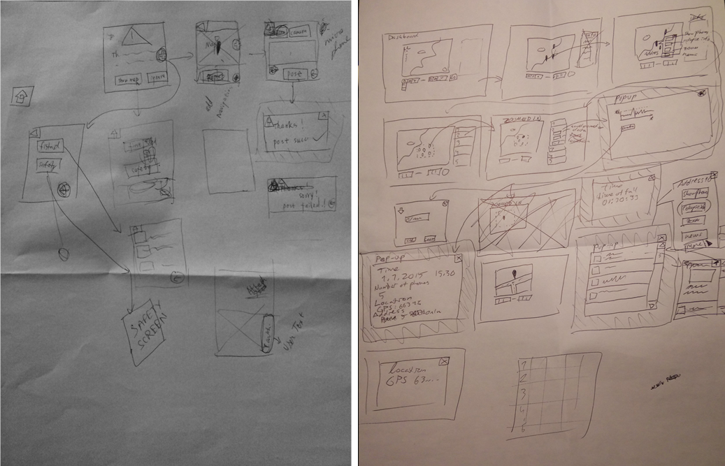

## Sketches

The paper wireframes were transformed into interactive prototypes using the Axure software [9].

### Mobile UI

Few screenshots of the Mobile UI are shown below. The full list of Mobile UI screenshots is available [online](https://www.dropbox.com/sh/2q9qyr0bhbfd09r/AADKOm9MNjJ6716mxKWO69nIa?dl=0).

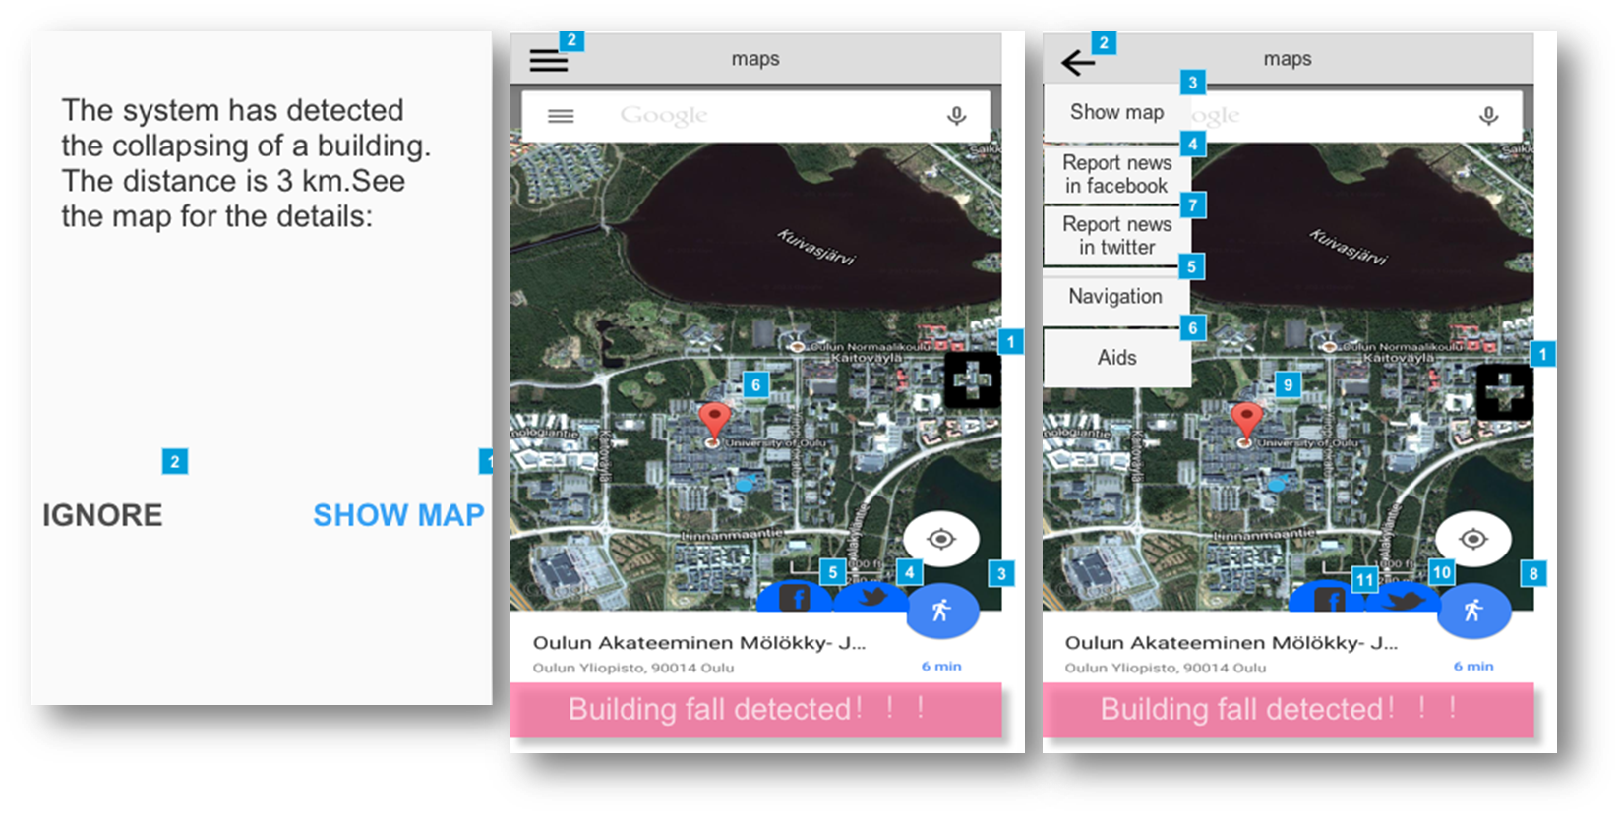

**Figure 11.** Mobile UI: Alert, Maps, and Maps with options

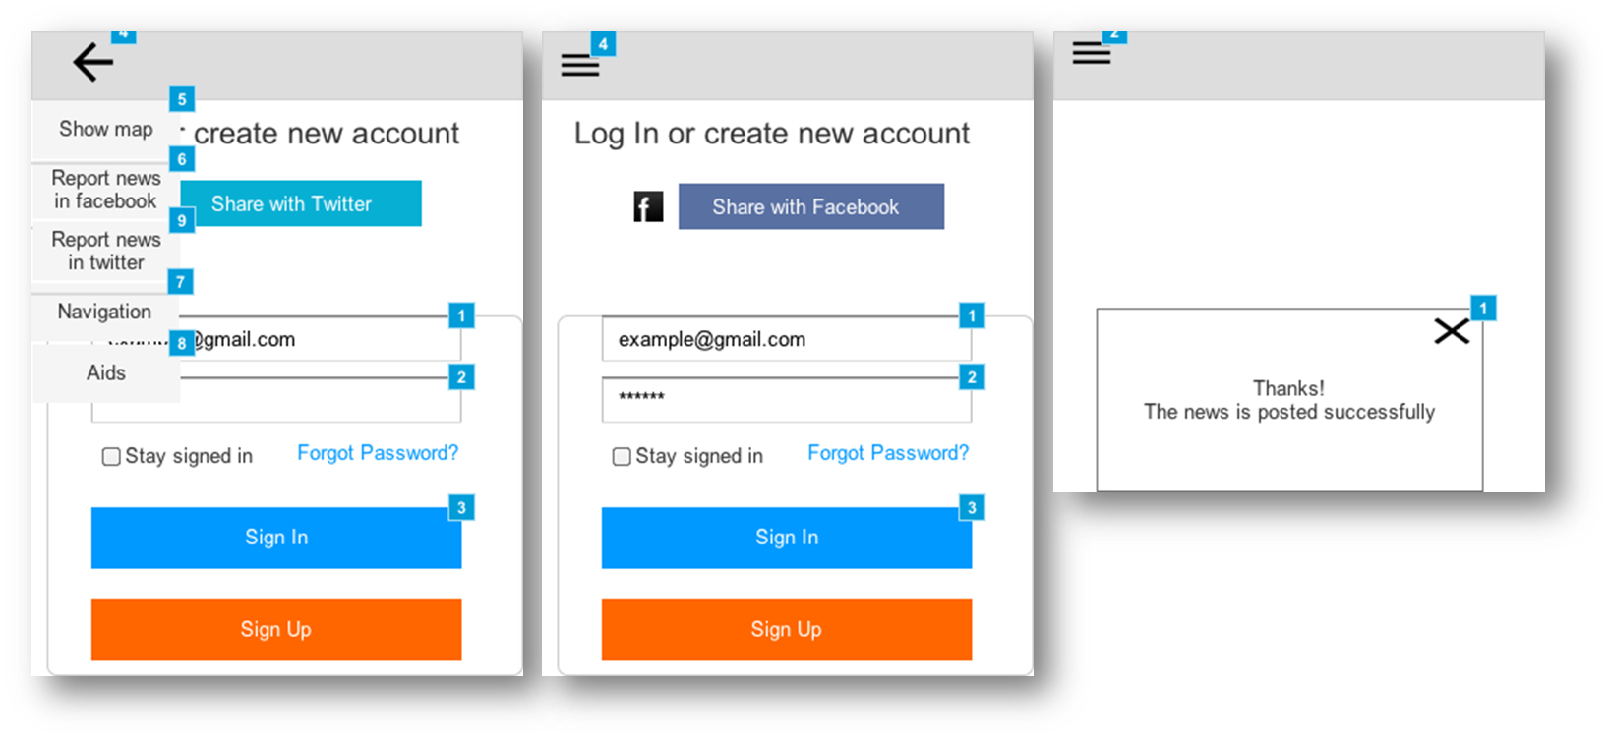

**Figure 12.** Post on Twitter, Post on Facebook, and posted successfully

### Web UI

Few screenshots of the Web UI are shown below. The full list of Web UI screenshots is available [online](https://drive.google.com/folderview?id=0BxDydheKGetuRFhESklWVFBZelE&usp=sharing).

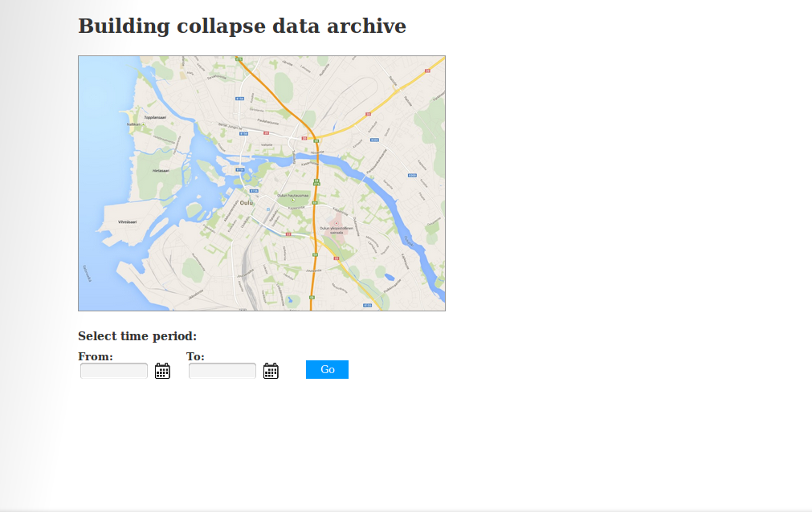

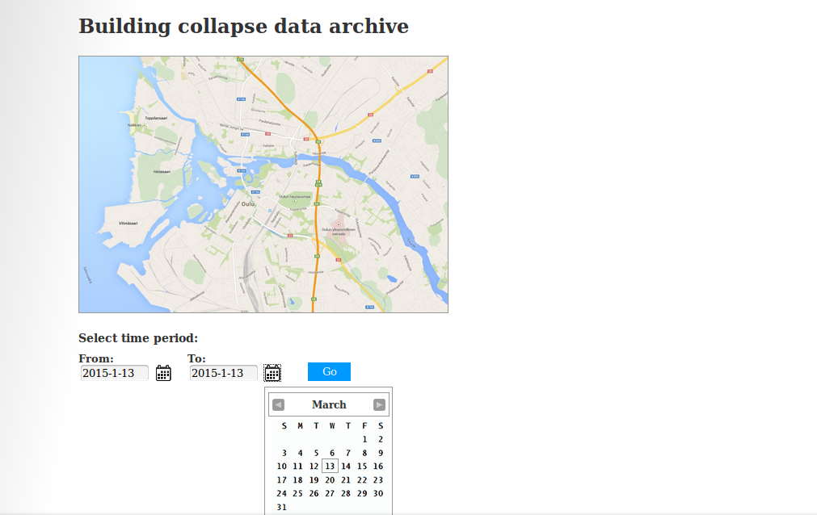

# Evaluation analysis

## Heuristic Evaluation

Heuristic Evaluation (originally proposed by Nielsen and Molich, 1990) was performed on the early-wireframes as it is a quick, cheap, and easy evaluation method of user interfaces.

## Web interface

### Method

#### Participant(s)

The evaluator was one of our team members who had not taken part in the interface design. The evaluator had substantial previous experience in performing HE.

#### Design

We created a scenario and 3 tasks for the evaluator to perform.

##### Scenario

You are a seismologist at the Japan Meteorological Agency. A massive earthquake had hit the coastal area and you have been asked to perform a post-earthquake analysis of the accelerometer data received from the smartphones which had subscribed to the Building Fall Detection System.

##### Task 1

Find the total number of collapsed building.

##### Task 2

Find the total number of phones that detected the fall of the State Tower building.

##### Task 3

Find news articles posted by the locals during the earthquake.

#### Materials

The early-wireframes were hand drawn on paper. A notebook was used to take notes during the evaluation. A printed copy of the 10 Usability Heuristics for User Interface Design was also provided.

#### Procedure

The HE was performed in a meeting room to ensure an undisturbed evaluation environment. The evaluator was seated and provided with the early-wireframes of the system interface. One of the interface designers took an adjacent seat and was responsible for guiding the navigation. This was necessary as the wireframes were pencil drawings and not interactive in nature. The evaluator worked his way through the tasks, simultaneously reviewing the interface in the light of the 10 Usability Heuristics. He reported problems and bottlenecks for each web page. After the evaluation, the evaluator suggested few changes that could enhance user experience and provided general feedback.

## Mobile interface

### Method

#### Participants

The evaluators were two of our team members who had not taken part in the interface design. The evaluators had substantial previous experience in performing HE.

#### Design

We created a scenario and described 4 goals for the evaluators to achieve.

##### Scenario

You are a student currently studying in an area that is highly prone to earthquakes. You have subscribed to the new Building Fall Detection System using your smartphone. While jogging you receive a alert message that notifies you of an earthquake that just took place a few kilometers away from your usual jogging track. The system is capable of meeting the below goals.

##### Goal 1

Users should be able to determine their distance from the building collapsed site.

##### Goal 2

Users should be able to navigate to the building collapsed site.

##### Goal 3

User should be able to access first-aid and safety information.

##### Goal 4

User should be able to participate in creating and publishing localized news to social networking sites.

#### Materials

The early-wireframes were hand drawn on paper. A notebook was used to take notes during the evaluation. Printed copies of the 10 Usability Heuristics for User Interface Design was also provided.

#### Procedure

The HE was performed in a meeting room to ensure an undisturbed evaluation environment. The evaluators were seated and provided with the early-wireframes of the system interface. This was a group evaluation (2 evaluators) and the evaluators were allowed to discuss among themselves. One of the interface designers took an adjacent seat and was responsible for guiding the navigation. This was necessary as the wireframes were pencil drawings and not interactive in nature. The evaluators were asked to achieve the goals by working their way through the tasks. They decided to break each of the the goals down into their appropriate tasks, and test each in turn. They were encouraged to report all problems irrespective of the severity level. The evaluators reviewed the interface in the light of the 10 Usability Heuristics. After the evaluation, they suggested few changes that could enhance user experience and provided general feedback.

# Implementation (TODO)

The next stage of the project requires us to implement the proposed solution that is discussed in this design document. We have decided to follow an ‘inspect-and-adapt’ approach. It is a form of the agile methodology of software development lifecycle that introduces flexibilities by relying on empirical results rather than guessing the ideal solution.

The various components of our system will be developed in parallel and will be aggregated together at the end of the cycle. As we have identified the basic capabilities of our system (based on use cases), we should not have much problems developing them. Each individual component can be evaluated/tested to check if it meets the requirement needs. To reiterate, we are focusing on the modularity and the reusability of the system.

In summary, during the implementation stage we shall,

1. Build an android plugin for sensing data on the phones by utilizing its accelerometer, gyroscope, GPS/location, and precise time data.
2. Our server side implementation will receive ‘Fall’ events from the smartphones and will analyze the data to determine ‘Positive’ collapse events. The server will also send alert notifications to the plugin to confirm/notify about the earthquake events.

# Conclusion

The design document lays the ground work for the implementation stage. We used an exploratory approach for identifying the stakeholders of the system, and created personas and scenarios based on it. Creating SONs earlier in the design phase gave us a better understanding of the capabilities and constraints of the system which we gracefully converted to use cases. The system design is a detailed explanation of how the system is expected to work and how the various components of the system interact with each other. We have also clearly indicated our second iteration of user interfaces having performed an expert evaluation on the initial paper wireframes. Lastly, we have indicated our plan for the implementation phase having taken into consideration the time and work-force constraints.

We plan to achieve a modular system that is easily upgradable, and additional functionalities can be added without hassles. We are also focusing on the reusability of the core ‘Plugin’ system, which can later be adapted by other researchers to add more functionalities. Finally, we believe that our system is not intended as a replacement for traditional monitoring networks, but rather as a supplement to increase the effectiveness of conventional earthquake monitoring systems.

# References

[1] N. Choices, “First aid - CPR - NHS Choices.” [Online]. Available: http://www.nhs.uk/conditions/Accidents-and-first-aid/Pages/CPR.aspx. [Accessed: 21-Jan-2015].

[2] BBC, “Earthquake.” [Online]. Available: http://www.bbc.co.uk/schools/gcsebitesize/geography/natural_hazards/earthquakes_rev1.shtml. [Accessed: 14-Nov-2014].

[3] “What is MEMS Technology?” [Online]. Available: https://www.mems-exchange.org/MEMS/what-is.html. [Accessed: 21-Jan-2015].

[4] “The Modified Mercalli Intensity Scale.” [Online]. Available: http://earthquake.usgs.gov/learn/topics/mercalli.php. [Accessed: 21-Jan-2015].

[5] “What Is a Seismometer? (with pictures).” [Online]. Available: http://www.wisegeek.com/what-is-a-seismometer.htm. [Accessed: 21-Jan-2015].

[6] “What is two-tier? - A Word Definition From the Webopedia Computer Dictionary.” [Online]. Available: http://www.webopedia.com/TERM/T/two_tier.html. [Accessed: 21-Jan-2015].

[7] “Usability First - Introduction to User-Centered Design | Usability First.” [Online]. Available: http://www.usabilityfirst.com/about-usability/introduction-to-user-centered-design/. [Accessed: 21-Jan-2015].

[8] “10 Heuristics for User Interface Design: Article by Jakob Nielsen.” [Online]. Available: http://www.nngroup.com/articles/ten-usability-heuristics/. [Accessed: 22-Jan-2015].

[9] “Interactive Wireframe Software & Mockup Tool | Axure.” [Online]. Available: http://www.axure.com/. [Accessed: 22-Jan-2015].

[10] D. Wald and V. Quitoriano, “TriNet ‘ShakeMaps’: Rapid generation of peak ground motion and intensity maps for earthquakes in southern California,” *Earthq.  …*, 1999.

[11] R. Clayton and T. Heaton, “Community seismic network,” *Ann.  …*, 2012.

[12] D. Wald and V. Quitoriano, “Utilization of the Internet for rapid community intensity maps,” *Seismol.  …*, 1999.

[13] “About Community Internet Intensity Maps,” Oct. 2000.

[14] “Sensors Overview | Android Developers.” .

[15] J. Reilly, S. Dashti, and M. Ervasti, “Mobile Phones as Seismologic Sensors: Automating Data Extraction for the iShake System,” *Autom. Sci.  …*, 2013.

[16] A. Coburm, “Factors determining human casualty levels in earthquakes: mortality prediction in building collapse,” *Proc. tenth  …*, 1992.

[17] K. Shiono, F. Krimgold, and Y. Ohta, “A method for the estimation of earthquake fatalities and its applicability to the global macro-zonation of human casualty risk,” *Proc. Fourth Int. Conf. Seism.  …*, 1991.

[18] F. Yamazaki, A. Nishimura, and Y. Ueno, “Estimation of human casualties due to urban earthquakes,” *Proc. 11th World …*, 1996.

[19] Y. Hirayama, “Collapse and reconstruction: Housing recovery policy in Kobe after the Hanshin Great Earthquake,” *Hous. Stud.*, 2000.

[20] L. Nielsen, “Personas,” *Encycl. Human-Computer Interact. 2nd Ed.*, 2014.

[21] “Patterns | Android Developers.” [Online]. Available: https://developer.android.com/design/patterns/index.html. [Accessed: 26-Jan-2015].

[22] “Yahoo Pattern Library.” [Online]. Available: http://developer.yahoo.com/ypatterns/everything.html.

[23] M. Faulkner and M. Olson, “The next big one: Detecting earthquakes and other rare events from community-based sensors,” *…  Sens. Networks …*, 2011.

[24] D. Ferreira, “AWARE: A mobile context instrumentation middleware to collaboratively understand human behavior,” *Univ. Oulu*, 2013.

[25] “UX process.” [Online]. Available: http://www.pinterest.com/pin/309622543106933374/.

# Contributions

All members equally participated in the team meetings and helped each other during the within-team deliverables. Below is a breakdown of the contribution of each team member.

## Team Meetings:

10 weeks: 2 hours each - 20 hrs. All team members were present during the meeting.

## Individual Contributions

### Zeyun Zhu

I am the project manager of the team and have been entrusted with some additional project management duties. It was my duty to ensure that we have proper team meetings every week. I also charted our plan for the design stage, having provided ideas on how to start the project ideation. As a team member, I contributed through my literature research on the topic, inputs during System design, and creating initial mobile UI wireframes for the end user and later converting them to Axure prototypes. Below is a breakdown of my total effort during this stage.

|  |  |
| --- | --- |
| Topic | Hours |
| Project Management | 2 |
| Literature Research | 20 |
| System Design | 10 |
| Mobile UI wireframes - paper | 3 |
| Mobile UI Axure prototypes | 20 |
| Report writing | 10 |
| **Total** | **65** |

**Table 4.** Zeyun Zhu working hours

### Haejong Dong

I have contributed towards our system architecture and the method of solving the given problem by going through previous related research materials. I spent significant amount of time to understand and identify the needs and also tried to study some of the past major earthquakes. This provided us some motivation for the current research. I also designed the system class diagram to help articulate our system better which will help us during the system implementation phase.

|  |  |
| --- | --- |
| Topic | Hours |
| Literature Research | 30 |
| Case Study | 10 |
| Class Diagram | 25 |
| Expert Evaluation | 3 |
| **Total** | **68** |

**Table 5.** Hejong Dong working hours

### Perttu Pitkänen

I contributed to the project by proving a concise list of literatures that have used mobile for monitoring earthquakes. I was also responsible to conduct a case study on earthquakes and how people behave during such catastrophic events. I provided my inputs to the overview of the System design, created web UI wireframes on paper and later did the same using Axure prototyping tool. I also played a crucial role in ideating the collapse detection algorithm and how the system should work under normal conditions. Below is a breakdown of my total effort during this stage.

|  |  |
| --- | --- |
| Topic | Hours |
| Literature Research | 15 |
| Case Study | 8 |
| System Design | 10 |
| Collapse detection algorithm | 8 |
| Web UI wireframes - paper | 3 |
| Web UI Axure prototypes | 6 |
| Presentation Slides | 3 |
| **Total** | **53** |

**Table 6.** Perttu Pitkänen working hours

### Pratyush Pandab

I put forth the idea to follow a UCD process and laid some ground rules on how to proceed. I started by reading research papers related to smartphone usage in earthquake monitoring and the algorithms used to increase the efficiency of the system. After understanding the concept of ‘how smartphones are being used in the monitoring process’, I proceeded to perform a Requirements Analysis on the given problem statement. I created the Statement of Needs corresponding to each user, which made it easier for me to complete the Use Cases. I also designed the entire Sequence Diagram of the system and finalized the Collapse detection algorithm to be used later in the implementation. I also contributed to the System Design Architecture, Expert Evaluation, and Report writing. Below is a breakdown of my total effort during this stage.

|  |  |
| --- | --- |
| Topic | Hours |
| Literature Research | 10 |
| Requirements Analysis | 7 |
| Use Cases | 5 |
| Sequence Diagram | 7 |
| Collapse detection algorithm | 10 |
| System Design Architecture | 10 |
| Expert Evaluation | 3 |
| Report writing | 13 |
| **Total** | **65** |

**Table 7.** Pratyush Pandab working hours

## Summary

The table summarizes the contribution of each of the team members to this design phase.

|  |  |  |
| --- | --- | --- |
| Name | Total Work in Hours | Contribution to the Total (%) |
| Zeyun | 65 | 25.90 |
| Haejong | 68 | 27.09 |
| Perttu | 53 | 21.12 |
| Pratyush | 65 | 25.90 |
| **Total** | **251** | **100** |

**Table 8.** Summary table of total work load and individual contributions

# Appendix

All documents can be found on the Google Drive: [Applied Computing Project](https://drive.google.com/folderview?id=0BwySVDqqosqBRVJxbThLcWVkVGM&usp=sharing)